A.C.E. (Answer, Challenge, Excel)
-a place to improve yourself

Submitted By

Student Name | Student ID
Md. Talim Afrid Tomal | 0242310005101319
Nafish Imtiaz Imti | 0242310005101930
Jannat Akter Duli | 0242310005101917
Md. Sajid Islam | 0242310005101579
Emon Kumer Sarkar | 0242310005101548

MINI LAB PROJECT REPORT
This Report Presented in Partial Fulfillment of the course
CSE312: Database Management System in the Computer Science and Engineering Department



DAFFODIL INTERNATIONAL UNIVERSITY
Dhaka, Bangladesh
April 16, 2025

DECLARATION
We hereby declare that this lab project has been done by us under the supervision of Mr. Mayen Uddin Mojumdar, Lecturer(Senior Scale), Department of Computer Science and Engineering, Daffodil International University. We also declare that neither this project nor any part of this project has been submitted elsewhere as lab projects.

Submitted To:

Mr. Mayen Uddin Mojumdar
Lecturer (Senior Scale)
Department of Computer Science and Engineering Daffodil International University

Submitted by



Md. Talim Afrid Tomal
ID: 0242310005101319
Dept. of CSE, DIU
  Nafish Imtiaz Imti  ID: 0242310005101930  Dept. of CSE, DIU |   Jannat Akter Duli  ID: 0242310005101917  Dept. of CSE, DIU
  Md. Sajid Islam  ID: 0242310005101579  Dept. of CSE, DIU |   Emon Kumer Sarkar  ID: 0242310005101548  Dept. of CSE, DIU

COURSE & PROGRAM OUTCOME

The following course have course outcomes as following:.

Table 1: Course Outcome Statements
CO’s | Statements
CO1 | Demonstrate a comprehensive understanding of fundamental database management concepts, including the relational data model, normalization techniques, and SQL basics.
CO2 | Design, implement and optimize relational databases, incorporating advanced SQL queries, indexing techniques and query optimization strategies.
CO3 | Understand and Analyze security measures, distributed database architectures and emerging trends in database management, demonstrating an understanding of the broader context and challenges in the field.

Table 2: Mapping of CO, PO, Blooms, KP and CEP
CO | PO | Blooms | KP | CEP
CO1 | PO1 | C2, A2, P2 | K2, K3, K4, K8 | EP1, EP4
CO2 | PO3 | C3, A3, P3 | K2, K3, K4, K6, K8 | EP1, EP2, EP7
CO3 | PO5 | C3, A4, P3 | K6 | EP4

The mapping justification of this table is provided in section 4.3.1, 4.3.2 and 4.3.3.

Table of Contents

Declaration i

Course & Program Outcome ii
- Introduction 1
  - Introduction 1
  - Motivation 1
  - Objectives 2
  - Feasibility Study 2
  - Gap Analysis 3
  - Project Outcome 3
- Proposed Methodology/Architecture 5
  - Requirement Analysis & Design Specification 5
    - Overview 5
    - Proposed Methodology/ System Design 5
    - Entity Relationship Diagram(ERD) 6
    - Schema Design(Crowfoot Notation) 7
    - UI Design 7
  - Overall Project Plan 10
- Implementation and Results 11
  - Implementation 11
  - Performance Analysis 12
  - Results and Discussion 12
- Engineering Standards and Mapping 15
  - Impact on Society, Environment and Sustainability 15
    - Impact on Life 15
    - Impact on Society & Environment 15
    - Ethical Aspects 15
    - Sustainability Plan 15
  - Project Management and Team Work 15
  - Complex Engineering Problem 16
    - Mapping of Program Outcome 16

    - Complex Problem Solving 17
    - Engineering Activities 17
- Conclusion 8
  - Summary 18
  - Limitation 18
  - Future Work 19
References 20

Chapter 1

Introduction

This chapter outlines our inspiration, objectives, and background research that guided us toward achieving a specific outcome aimed at serving society and solving a real-world problem.

Introduction
In the evolving landscape of education, especially in the digital age, the need for efficient and accessible self-assessment tools has become increasingly important. Traditional assessment methods are often limited by manual effort, time constraints, and lack of personalized feedback. With students seeking more flexibility in learning and evaluation, and faculty needing streamlined ways to create and manage quizzes, a digital solution becomes essential.
The project titled A.C.E. (Answer, Challenge, Excel) addresses this gap by offering a web-based quiz and self-assessment platform. The system is designed to allow students to evaluate their learning by entering a specific course name or quiz code, enabling quick access to relevant quizzes. Simultaneously, it empowers faculty members to create, manage, and assign quizzes efficiently, without relying on complex tools or third-party applications.
This platform not only supports automated grading and feedback, but also focuses on simplicity, security, and scalability. It is built using Python with Django for the backend and uses MariaDB as the database solution, ensuring reliable performance and easy maintenance.
By providing an integrated and structured approach to digital assessments, A.C.E. aims to make learning more engaging and result-oriented. It helps students track their performance while reducing the faculty's administrative workload, thus contributing to a smarter and more efficient academic environment.

Motivation
The primary computational motivation behind the development of A.C.E. (Answer, Challenge, Excel) stems from the growing need for digital transformation in academic assessments. As students and educators increasingly rely on online learning environments, the absence of a centralized, efficient, and user-friendly platform for conducting quizzes and self-assessments becomes a significant barrier. Traditional paper-based evaluations and unstructured digital tools are not only time-consuming but also lack the ability to provide instant feedback, analytics, and accessibility from remote locations.
Our motivation was to bridge this gap by designing a system that automates quiz creation, delivery, and evaluation. Leveraging the capabilities of Django and relational databases, we aimed to build a robust and scalable solution that simplifies the assessment process for both students and faculty. The project gave us an opportunity to apply computational thinking and backend logic to solve a practical problem using real-world technologies.
Solving this problem benefits us by enhancing our understanding of database design, web development frameworks, authentication mechanisms, and user interaction in web-based systems. It also prepares us for future roles in the tech industry where designing efficient systems that solve meaningful problems is crucial. Moreover, contributing to an educational solution aligns with our academic values and offers a sense of purpose in creating something that could potentially aid institutions in modernizing their evaluation processes.

Objectives
The objectives of the project A.C.E. (Answer, Challenge, Excel) are defined in clear and specific terms as follows:
- To Develop a Web-Based Quiz Platform: Design and implement an interactive online platform where users can access and participate in quizzes using course names or unique quiz codes.
- To Enable Faculty to Create and Manage Quizzes Easily: Provide faculty members with an intuitive interface to create, edit, and manage quizzes, including adding questions, setting correct answers, and defining scoring criteria.
- To Automate Evaluation and Provide Instant Feedback: Implement backend logic to automatically evaluate student responses and generate immediate feedback, helping users understand their performance instantly.
- To Design a Scalable and Maintainable Database Structure: Use MariaDB to build a normalized, efficient database schema capable of handling multiple users, quizzes, and results while maintaining data integrity.
- To Facilitate Self-Assessment for Students: Empower students to monitor their learning progress by providing access to past attempts, results history, and performance summaries.
- To Apply Practical Knowledge of Django and SQL: Gain hands-on experience with Django as a web framework and SQL-based database management by applying classroom knowledge to solve a real-world problem.

Feasibility Study
To assess the viability and relevance of our project, we conducted a review of similar research studies, existing web applications, and digital assessment platforms. This analysis helped us understand existing methodologies, identify gaps, and validate the need for a new solution like A.C.E.
Several educational technology studies highlight the importance of formative assessment tools in improving student engagement and academic performance. In particular, studies such as demonstrate that automated self-assessment platforms lead to increased learning retention and confidence. Tools like Moodle and Google Forms have been used in case studies for quiz delivery, but they often lack a dedicated, lightweight solution that is both custom-built and focused on quiz-based evaluation alone.
Platforms such as Google Classroom, Kahoot, and Quizizz offer quiz features, but they often include additional complexities like class management, grading systems, or gamified elements that may not align with institutions seeking a more academic-focused tool. Additionally, many of these platforms rely on internet stability and are not always open-source or customizable. Our project narrows the focus to a streamlined quiz system with role-based access and self-assessment capabilities, making it ideal for minimalistic or institution-specific use.
Existing systems tend to focus more on interface and user interaction, whereas A.C.E. contributes on the methodological side by offering a simplified backend that separates roles, handles automatic evaluation, and generates performance summaries — all while using open-source technologies like Django and MariaDB. The emphasis on quiz-code-based access, rather than complete course integration, also introduces a unique, scalable, and time-saving feature.

Gap Analysis
Despite the availability of several online assessment platforms, there are noticeable gaps that our project, A.C.E. (Answer, Challenge, Excel), aims to address:
- Lack of Lightweight and Focused Solutions: Most existing platforms like Google Classroom, Moodle, and Kahoot are part of broader learning management systems or gamified environments. These systems often come with unnecessary features for institutions or individuals looking for a simple, quiz-focused platform. Our system fills this gap by offering a dedicated quiz and self-assessment platform with minimal overhead.
- Limited Role-Based Control and Customization: Many platforms do not provide flexible role-based access or limit administrative control to predefined functions. A.C.E. allows distinct functionalities for faculty (quiz creation and management) and students (quiz access and result viewing), which is essential for maintaining academic workflow and user separation.
- Dependency on Third-Party Services: Existing tools are often hosted externally or come with subscription fees and data privacy concerns. There is a need for a custom-built, self-hosted solution that institutions or developers can fully control. Our platform closes this gap by being open-source, allowing for full ownership and customization.
- No Quiz-Code Based Access System: Most tools require full enrollment in a course or class, which may not be ideal for quick or one-time assessments. A.C.E. introduces a quiz code or course name-based access system, enabling faster self-assessment without the need for registration into specific class environments.
- Lack of Performance Tracking in Simple Tools: Tools like Google Forms allow quizzes but lack structured performance tracking over time. Our system addresses this by storing and displaying student results, attempts history, and progress, which helps users monitor their improvement.

Project Outcome
What The development of A.C.E. (Answer, Challenge, Excel) has resulted in several key outcomes that reflect both the technical success of the project and its practical relevance in academic environments. These outcomes are listed below:
- Functional Web-Based Assessment Platform: A fully working, role-based online quiz platform was developed, enabling faculty to create quizzes and students to attempt them using course names or quiz codes. The system includes user authentication, dynamic question handling, and auto-evaluation features.
- Improved Learning and Evaluation Experience: The platform simplifies the assessment process for students and allows them to evaluate their understanding at their own space. It encourages self-learning and helps identify areas for improvement through detailed result summaries.
- Streamlined Faculty Workflow: Faculty members can now design, edit, and manage quizzes without manual effort or third-party tools. This reduces administrative workload and allows more focus on academic content delivery.
- Hands-On Experience with Real-World Technologies: The project gave us valuable experience with full-stack development, particularly using Django (Python framework), MariaDB, and web design principles. We gained practical skills in system design, authentication, backend logic, and database integration.
- Contribution to Digital Education Tools: This project adds to the growing pool of open, customizable educational technology tools, potentially serving as a base for further development in institutions or by independent educators.
- Personal and Academic Growth: As developers, we enhanced our problem-solving, project management, and software development skills, which will directly benefit us in future academic or professional opportunities.
Chapter 2

Proposed Methodology/Architecture

This chapter discusses the proposed methodology and architectural design of the A.C.E. platform. It includes the requirement analysis, system design approach, user interface planning, and a roadmap of the overall project implementation.

Requirement Analysis & Design Specification

Overview
The development of the A.C.E. (Answer, Challenge, Excel) platform followed a structured and modular methodology that emphasized simplicity, usability, and efficiency. The system was designed using a layered architecture, primarily built on the Django framework, which implements the Model-View-Template (MVT) design pattern. This pattern separates data management, user interface, and control logic, ensuring maintainability and scalability.
The requirement analysis phase was carried out to identify the core functionalities necessary for an efficient quiz-giving and self-assessment platform. Based on the findings, the system was broken down into clearly defined modules such as User Management, Quiz Management, Question Bank, and Result Analysis. Each module was developed and tested independently to ensure that the system met both functional and non-functional requirements.
The design specification focused on building a lightweight, role-based web application where faculty members could create and manage quizzes while students could participate and instantly review their results. Key considerations such as data security, user experience, and system responsiveness were prioritized throughout the development process.
In the following sections, we detail the system’s proposed methodology, UI design approach, and the overall project implementation plan that collectively contributed to the successful completion of the A.C.E. platform.

Proposed Methodology/ System Design
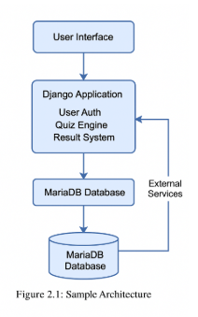
The system follows a modular architecture using the Model-View-Template (MVT) pattern provided by Django. It separates concerns between data handling (models), interface rendering (templates), and request-response logic (views).
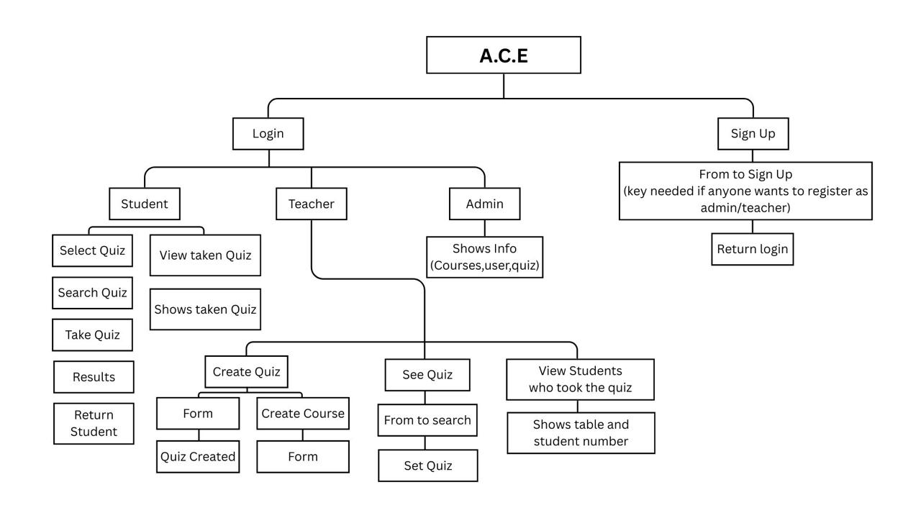
Figure 2.2: The workflow of the Application

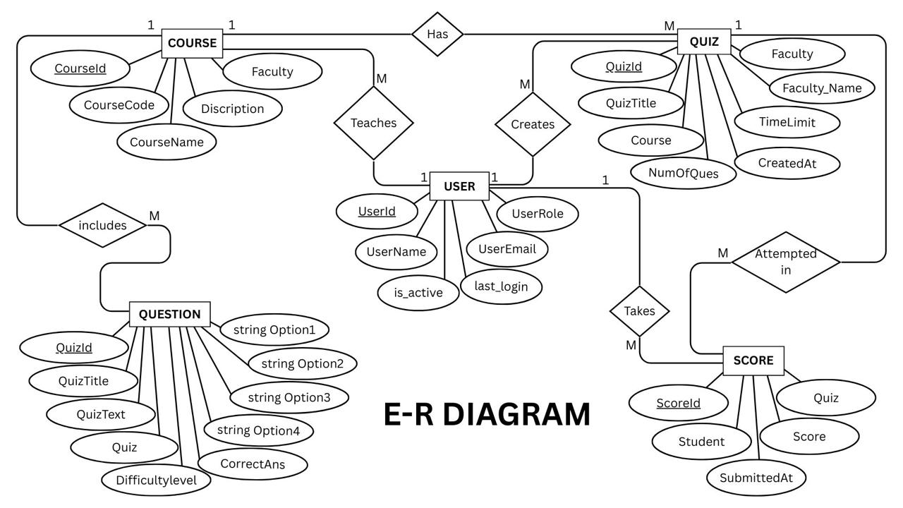
Entity Relationship Diagram(ERD)

Figure 2.3: The Entity-Relationship of the Application

Schema Design(Crowfoot Notation)

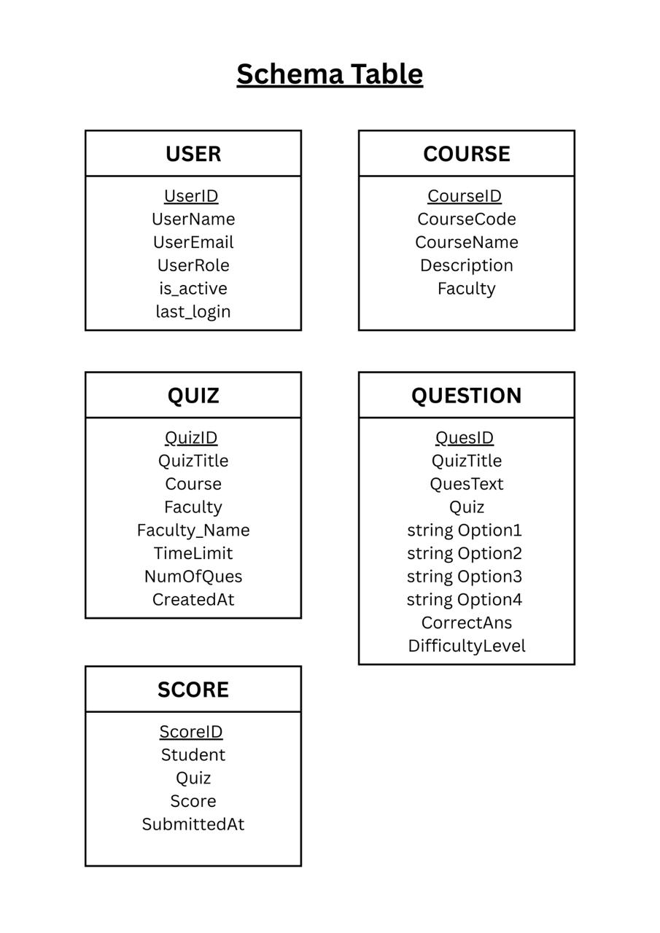
Figure 2.4: The Schema Table

UI Design
The user interface of the A.C.E. platform was designed with simplicity, clarity, and responsiveness in mind. The frontend was developed using HTML, CSS, and JavaScript. The interface was separated by user roles to streamline workflows and provide clear navigation.

Main UI Components:
- Landing Page / Home Screen
- Navigation to login or register
- Clean, minimal layout with branding and tagline
- Login / Registration Page
- Role-based login (faculty or student)
- Secure login form with validation
- Separate registration options for new users
- Admin Dashboard
- Menu: User Management, Course Management, Quiz Management
- Info and delete access on user, course, quiz
- Faculty Dashboard
- Menu: Create Quiz, View Quizzes, Analyze Results
- Form to add questions (MCQ, short answer, etc.)
- Student Dashboard
- Enter quiz code or select course
- View quiz instructions and attempt quiz
- Submit answers and receive instant results
- Access previous performance summaries
- Result Page
- Displays score, correct answers
- Option for retry from dashboard

Student Dashboard:

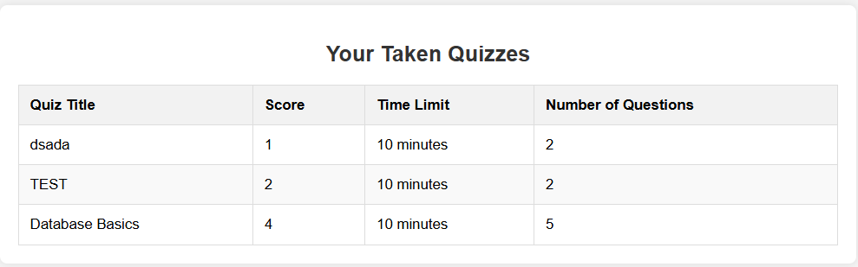

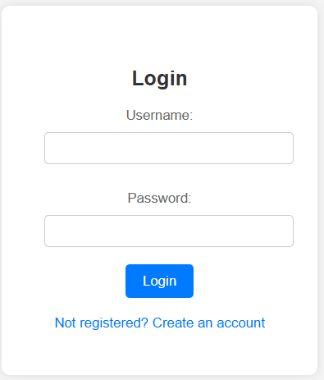
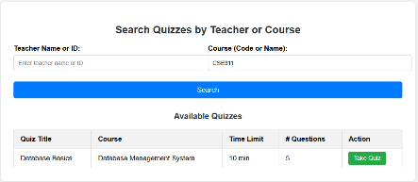
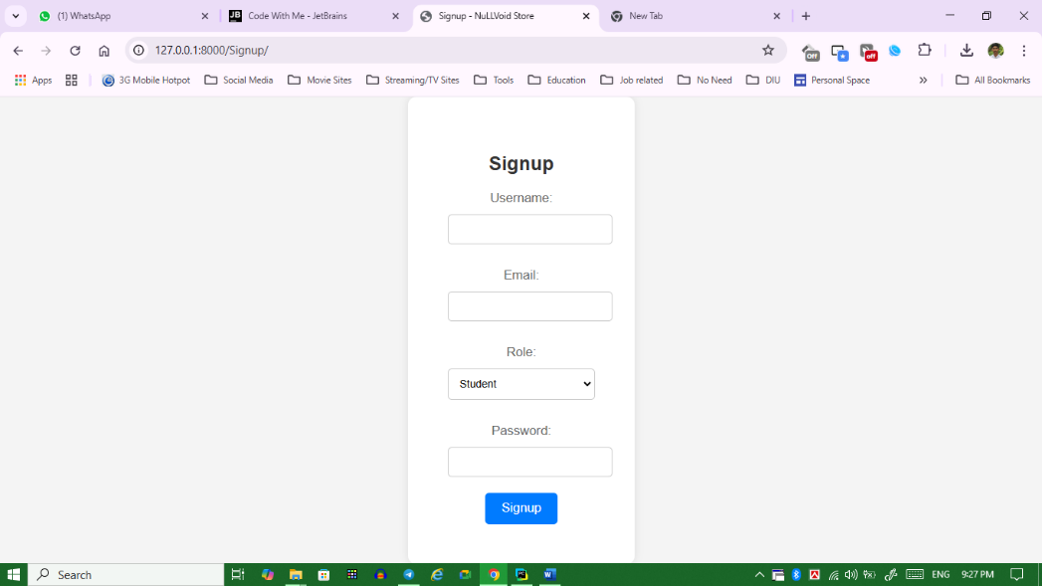

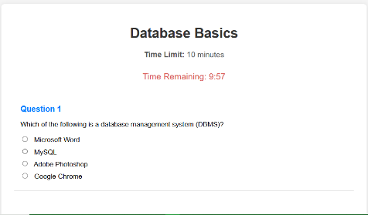

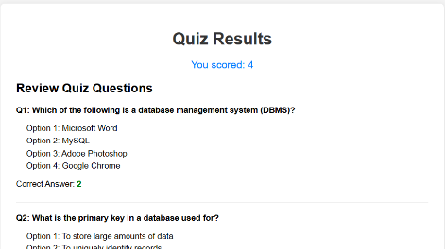

Admin Dashboard:

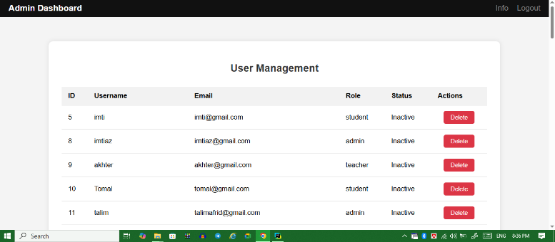
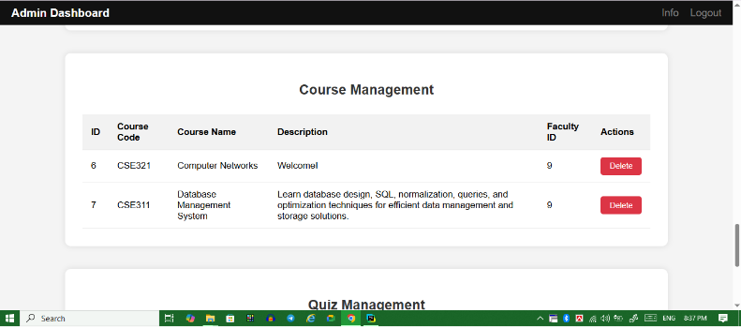
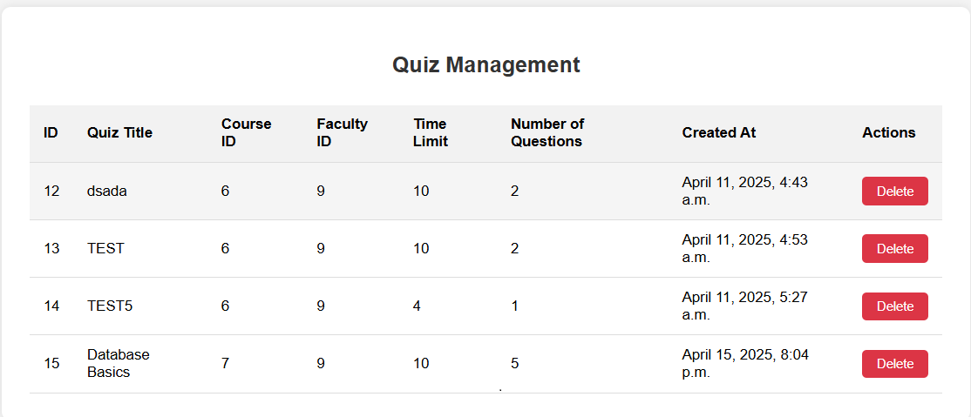

Faculty Dashboard:
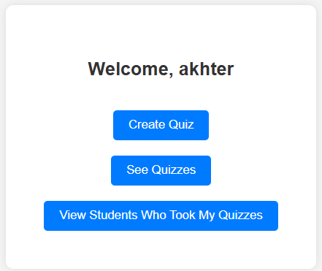
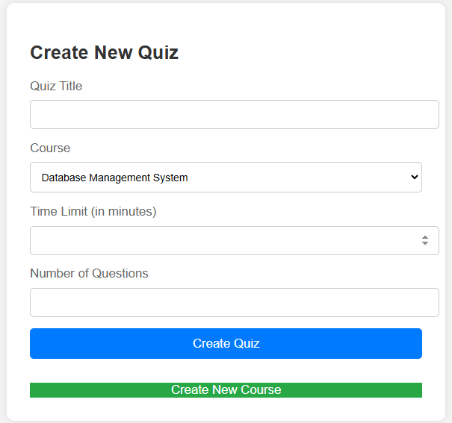
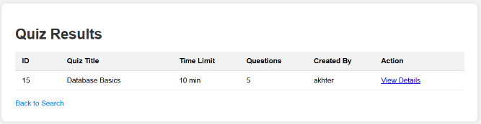
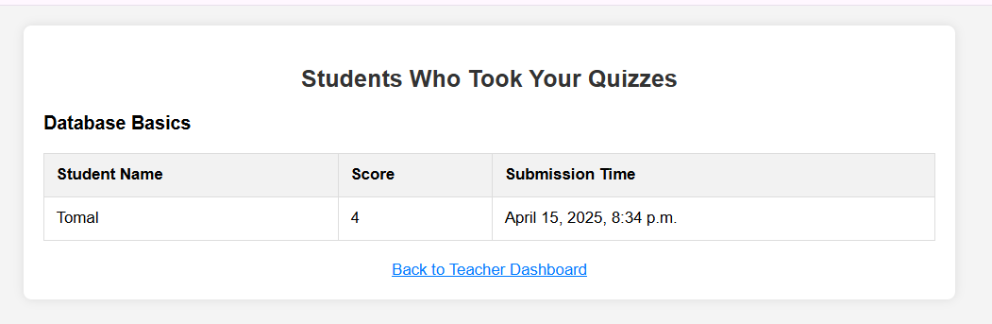

Overall Project Plan
Phase | Activities | Duration
Phase 1: Requirement Analysis | - Studied existing quiz platforms  - Identified key features  - Feasibility check (Django + MariaDB) | 4 days
Phase 2: System Design | - Designed ERD  -Define Schema  - UI layout planning  - Defined module flow and structure | 5 days
Phase 3: Implementation | - Developed backend logic with Django  - Created templates and views  - Integrated database (XAMPP/MySQL) | 10 days
Phase 4: Testing & Debugging | - Unit tested modules  - Bug fixing  - Verified quiz flow for users | 4 days
Phase 5: Deployment & Documentation | - Finalized interface  - Run full test cycle  - Prepared report & presentation | 3 days

Total Duration =26 days
Chapter 3

Implementation and Results

This chapter presents the implementation details of the A.C.E. (Answer, Challenge, Excel) system, followed by an analysis of its performance and a discussion of the results obtained during testing and trial runs. The system was implemented using Python (Django), and the testing was carried out in a local environment with a sample dataset.

Implementation
The A.C.E. (Answer, Challenge, Excel) system was developed using the Django web framework with Python for the backend and MariaDB (via XAMPP, MySQL) for database management. The system follows the Model-View-Template (MVT) architecture, which separates the business logic, user interface, and data models to improve scalability and maintainability.
Backend Development:
- Django Framework: The system uses Django to handle routing and other backend functionalities. The views.py file manages the logic behind different pages, such as handling login, sign-up, quiz creation, and submission.
- Database Integration: MariaDB was used as the database system, and XAMPP was employed to facilitate the local server setup. SQL queries, executed through Django's connection.cursor() method, were used for data manipulation, including inserting user data, querying quizzes, and updating scores.
- User Management: Custom user models and roles (admin, teacher, student, quiz, questions, score) were created to differentiate access levels. The UserManager class (defined in models.py) ensures proper management of user accounts, including password hashing and authentication.

Frontend Development:
- HTML, CSS, JavaScript: The front-end interface was developed using HTML, CSS, and JavaScript to ensure an intuitive, responsive design. Python HTML templates were utilized to render dynamic content, such as quiz questions, results, and user information.
- User Dashboards: The system provides customized dashboards for students, teachers, and admins. Students can take quizzes, view their scores. Teachers can create quizzes, add questions, and see student results. Admins have control over users, courses, and quizzes.

Key Features:
- Quiz Creation and Management: Teachers can create quizzes, add questions, and set parameters such as time limits and number of questions. Quizzes are linked to specific courses.
- Student Interaction: Students can take quizzes, view results, and track their progress. A search and filtering system allows students to find quizzes based on course, teacher.
- Admin Control: Admins have the ability to manage users (delete accounts) and manage quizzes and courses.

Performance Analysis
The performance of the A.C.E. system was evaluated during the testing phase, focusing on system responsiveness, accuracy in quiz results, and overall user experience. For this we ran some complex queries like double join subqueries with condition and it only took 0.0750 seconds. And when we ran the basic join queries with search(where), it only took 0.0006 seconds and showing all the rows in a table with SELECT *, it took 0.00005 seconds on average. Some of the queries we used to test the performance are given in the results from testing part in 3.3. Overall, the performance was satisfactory and met our required standards.

Results and Discussion
The implementation of the A.C.E. system achieved the desired outcomes for its primary objectives: providing a dynamic platform for quiz creation, management, and interaction between students and teachers.
Testing Environment:
- Local Environment: The system was tested locally with sample data using XAMPP (MySQL) as the database and Django's development server. All features were tested on standard desktop browsers (Chrome, Firefox).
- Database Queries: Database queries were optimized using indexing where necessary, especially for large datasets, such as querying quiz results and filtering quizzes by teacher or course. The system used SQL queries with parameterized inputs to avoid SQL injection vulnerabilities.
Results from Testing:
- Scalability: The system performed well with a moderate amount of pressure. Performance was tested by simulating quiz submissions and database queries, and the response time remained within acceptable limits. For example, the system efficiently handled the following SQL query, which retrieves quizzes with filtering based on teacher, course, and difficulty level:
SELECT q.QuizID, q.QuizTitle,
CASE
WHEN COUNT(CASE WHEN s.DifficultyLevel = 'hard' THEN 1 END) > COUNT(CASE WHEN s.DifficultyLevel = 'easy' THEN 1 END) THEN 'hard'
WHEN COUNT(CASE WHEN s.DifficultyLevel = 'medium' THEN 1 END) COUNT(CASE WHEN s.DifficultyLevel = 'easy' THEN 1 END) THEN 'medium'
ELSE 'easy'
END AS avg_difficulty,
q.TimeLimit, q.NumOfQues, u.UserName
FROM store_quiz q
JOIN store_user u ON q.Faculty_id = u.UserID
LEFT JOIN store_question s ON q.QuizID = s.Quiz_id
WHERE 1
GROUP BY q.QuizID, q.QuizTitle, q.TimeLimit, q.NumOfQues, u.UserName

This query efficiently filtered and displayed relevant quizzes based on teacher and course, even when multiple filters were applied.

- Accuracy: The scoring system was accurate, correctly calculating the student scores based on their answers and updating the database in real-time. For example, after the student submits the quiz, the following queries were executed to compute the score:
Fetching the correct answer for a specific question:
SELECT CorrectAns
FROM store_question
WHERE QuesID = %s AND Quiz_id = %s
This query was used to compare the student's answer with the correct one and calculate the score accordingly.

Saving the student's score after quiz submission:
INSERT INTO store_score (Student_id, Quiz_id, Score)
VALUES (%s, %s, %s)
After calculating the score, the system saved it in the store score table, ensuring real-time updates.

Updating the score if the student had previously taken the quiz:
UPDATE store score
SET Score = %s, SubmittedAt = NOW()
WHERE Student_id = %s AND Quiz_id = %s
This ensures that the system correctly updates existing records for students who retake a quiz or submit answers after a delay.

- User Experience: Users reported a smooth experience when navigating through quizzes and submitting answers. The responsive design ensures that the user will not face any jitter while using the application. To enhance user experience, queries like the following were used to retrieve quiz data for students without causing delays:
Fetching quiz questions to be presented to the student:
SELECT QuesText, Option1, Option2, Option3, Option4
FROM store_question
WHERE Quiz_id = %s
LIMIT %s
This query retrieved the relevant questions for a quiz, ensuring that the student received the correct content in a timely manner.

Fetching the student's score and quiz questions after submission:
SELECT Score
FROM store_score
WHERE Student_id = %s AND Quiz_id = %s
After the quiz submission, the system efficiently retrieved the student's score and allowed them to review their answers, providing immediate feedback and a smooth user experience.

Challenges and Solutions:
- Database Performance: The initial database queries, particularly for fetching large numbers of quizzes and results, experienced delays. This was mitigated by optimizing queries and adding indices to frequently queried fields, such as QuizID, UserID, and CourseID.
- User Authentication: Handling different user roles (admin, teacher, student) presented challenges in ensuring correct access control. This was addressed by using custom user roles in the User model

Chapter 4

Engineering Standards and Mapping

This chapter explores the broader impact of the A.C.E. project on individual lives, society, and the environment. It also considers ethical implications, sustainability plans, and how teamwork and project management were applied during the project’s development. Finally, a basic cost analysis is provided along with a proposed revenue model.

Impact on Society, Environment and Sustainability

Impact on Life
The A.C.E. platform empowers students by allowing them to assess their knowledge independently. It encourages self-paced learning and builds confidence before formal exams. For teachers, it simplifies the quiz creation and evaluation process, saving time and allowing a more targeted teaching approach.

Impact on Society & Environment
By digitizing the quiz process, A.C.E. minimizes the need for printed materials such as question papers and answer sheets, thereby reducing paper consumption. The platform can be used in educational institutions, coaching centers, or online learning platforms, promoting a sustainable and digital approach to education. In rural or underdeveloped regions, this platform can support e-learning initiatives and bridge digital gaps in assessments.

Ethical Aspects
The project adheres to ethical standards such as data privacy and user role restrictions. Only authenticated users can access the system, and quiz data is securely stored in the backend. No personal information is misused. The system was built to encourage honesty in self-assessment without promoting cheating or data manipulation.

Sustainability Plan
The system is designed to be lightweight, scalable, and maintainable. It can be deployed on cloud servers or local hosting platforms. Using open-source tools (Django, MariaDB, XAMPP), it reduces dependence on costly licenses. Future upgrades may include:
- Real-time analytics with minimal server load.
- Multi-language support for regional inclusiveness.
- Integration with school management systems for long-term scalability.

Project Management and Team Work
The project was divided into logical modules and managed through regular checkpoints and version control. Responsibilities were distributed among team members for planning, coding, UI design, database modeling, testing, and documentation. Collaboration tools like Git and Google Docs were used to enhance productivity and version tracking.
Team and work distribution:
SL | Name | Role | Responsibility
01 | Md. Talim Afrid Tomal | Project Manager | - Planned and supervised the entire project lifecycle  - Coordinated among team members and tracked progress  - Managed task distribution and deadlines
02 | Nafish Imtiaz Imti | Lead Developer | - Designed and implemented the backend system using Django  - Developed database schema using MariaDB  - Integrated modules and handled logic flow
03 | Jannat Akter Duli | UI/UX Designer | - Designed user interface layouts and pages  - Ensured intuitive and responsive UI  - Worked with frontend forms and templates using Django framework
04 | Md. Sajid Islam | Quality Assurance | - Tested each module to identify bugs and performance issues  - Conducted functional and UI testing  - Ensured system met functional requirements
05 | Emon Kumer Sarkar | Documentation Specialist | - Prepared project reports, SRS, and design documents  - Documented each phase of development  - Assisted in final report writing and formatting

Complex Engineering Problem

Mapping of Program Outcome
In this section, provide a mapping of the problem and provided solution with targeted Program Outcomes (PO’s).
Table 4.1: Justification of Program Outcomes
PO’s | Justification
PO1 | By mastering the relational data model, normalization principles, and SQL basics, we fulfill the program outcome of acquiring a solid foundation in fundamental database management concepts.  This knowledge forms the basis for advanced topics and practical applications in the field of database management systems, which is explicitly addressed in CO1 thus achieving PO1
PO3 | Designing and implementing relational databases require problem-solving skills and the ability to translate conceptual designs into practical database structures. By mastering advanced SQL queries,  indexing techniques, and query optimization, we develop the capability to design and implement effective database solutions to meet specific requirements, aligning with the program outcome focused on practical problem-solving abilities thus achieving PO3
PO5 | Understanding security measures, distributed database architectures, and emerging trends in database  management situates us within the broader context of contemporary issues and challenges in the field. By analyzing and evaluating these topics, students develop critical thinking skills and an awareness of the evolving landscape of database management systems, aligning with the program outcome focused on staying abreast of contemporary issues and trends in the discipline and thus achieving PO5

Complex Problem Solving
Table 4.2: Mapping with complex problem solving.
EP1  Range of Conflicting Requirements | EP2  Depth of Analysis | EP4  Familiarity of Issues | EP7  Interdependence
The project balances various stakeholder needs—students want a simple UI while faculty need robust features like timer-based quizzes and result analytics. This creates conflicting design and usability goals. | Requires in-depth analysis of relational database design, ERD modeling, normalization, user role management, and secure login systems. It also includes handling various query operations and constraints. | The platform deals with known but challenging problems such as authentication, session management, and user-based access control, which are familiar issues in web-based applications. | The system components are highly interconnected: user roles, quizzes, results, and the database all rely on each other for seamless functionality. Changes in one module affect others.
8, 9, 10 | 5, 6, 7, 8 | 12, 13, 14 | 11, 12

Engineering Activities

Table 4.3: Mapping with complex engineering activities.
EA1  Range of resources | EA2  Level of Interaction | EA4  Consequences for society and environment
Utilizes multiple technologies such as databases, backend frameworks, front-end tools, and local servers to create a fully functional educational platform. Used Django, python and MariaDB | Involves interaction between users, application interfaces, server-side logic, and the database, ensuring secure and dynamic operations. | Promotes digital education by enabling self-paced assessments, reducing paper use, and enhancing accessibility in learning environments.
11,12 | 5,6,7,8,9 | 15

Chapter 5

Conclusion

This chapter presents a conclusive summary of the entire project, discussing the core contributions, limitations encountered during development, and possible future enhancements that can improve the system’s effectiveness and reach.

Summary
The project A.C.E. (Answer, Challenge, Excel) aimed to provide a self-assessment and quiz management platform for students and faculty members. The main goal was to create a structured environment where students can evaluate their knowledge in a specific subject through custom quizzes, while faculty can create and manage those quizzes with ease.
The development included:
- A web-based interface developed using Django (Python).
- MariaDB/XAMPP for data storage and management.
- User authentication and role-based access control.
- Automatic result evaluation and feedback.
Through this project, we successfully demonstrated how technology can improve the process of academic evaluation and empower both learners and educators through a digital solution.

Limitation
Despite the successful implementation of the core functionalities, the system still has a few limitations:
- Lack of Real-Time Functionality: The platform currently does not support live or timed quizzes, which limits its use for time-bound assessments or online exams.
- Limited Analytical Insights: While basic results are shown, there is no advanced data visualization or topic-wise performance breakdown to help students understand their strengths and weaknesses.
- UI Constraints on Mobile Devices: The current design was tested primarily on desktops, it’s not available as smartphones and tablets versions yet.
- No Online Hosting: As the system is currently running in a local environment (XAMPP/MariaDB), it is not accessible over the internet for remote users.
- Single Language Support: The interface is available only in English, making it less inclusive for users who prefer content in their native language.

Future Work
To make the system more robust, scalable, and user-friendly, several improvements can be considered in future iterations:
- Integration of Real-Time and Timed Quizzes: Implementing timed quizzes and automatic submission will help simulate real exam conditions and broaden the use-case.
- Advanced Reporting & Analytics: Adding features like heatmaps, topic-wise accuracy charts, and trend analysis over multiple quizzes will benefit both students and teachers.
- Mobile App Development: A dedicated mobile app for Android/iOS can significantly increase accessibility and user engagement.
- Cloud-Based Hosting: Deploying the application on cloud platforms like AWS, Heroku, or Firebase will enhance availability, scalability, and real-time database access.
- Gamification Features: Adding leaderboards, badges, and progress tracking will encourage consistent usage and make learning more engaging.
- Multi-Language Interface: Providing options for users to switch to their preferred language will improve usability across diverse user groups.

References

[1] https://www.w3schools.com/django/
[2] https://www.reddit.com/r/django/
[3] https://docs.djangoproject.com/
[4] https://stackoverflow.com/questions/tagged/django
[5] https://github.com/search?q=django+quiz+app

